Task 3:

Answer:

27.10.17 14:33

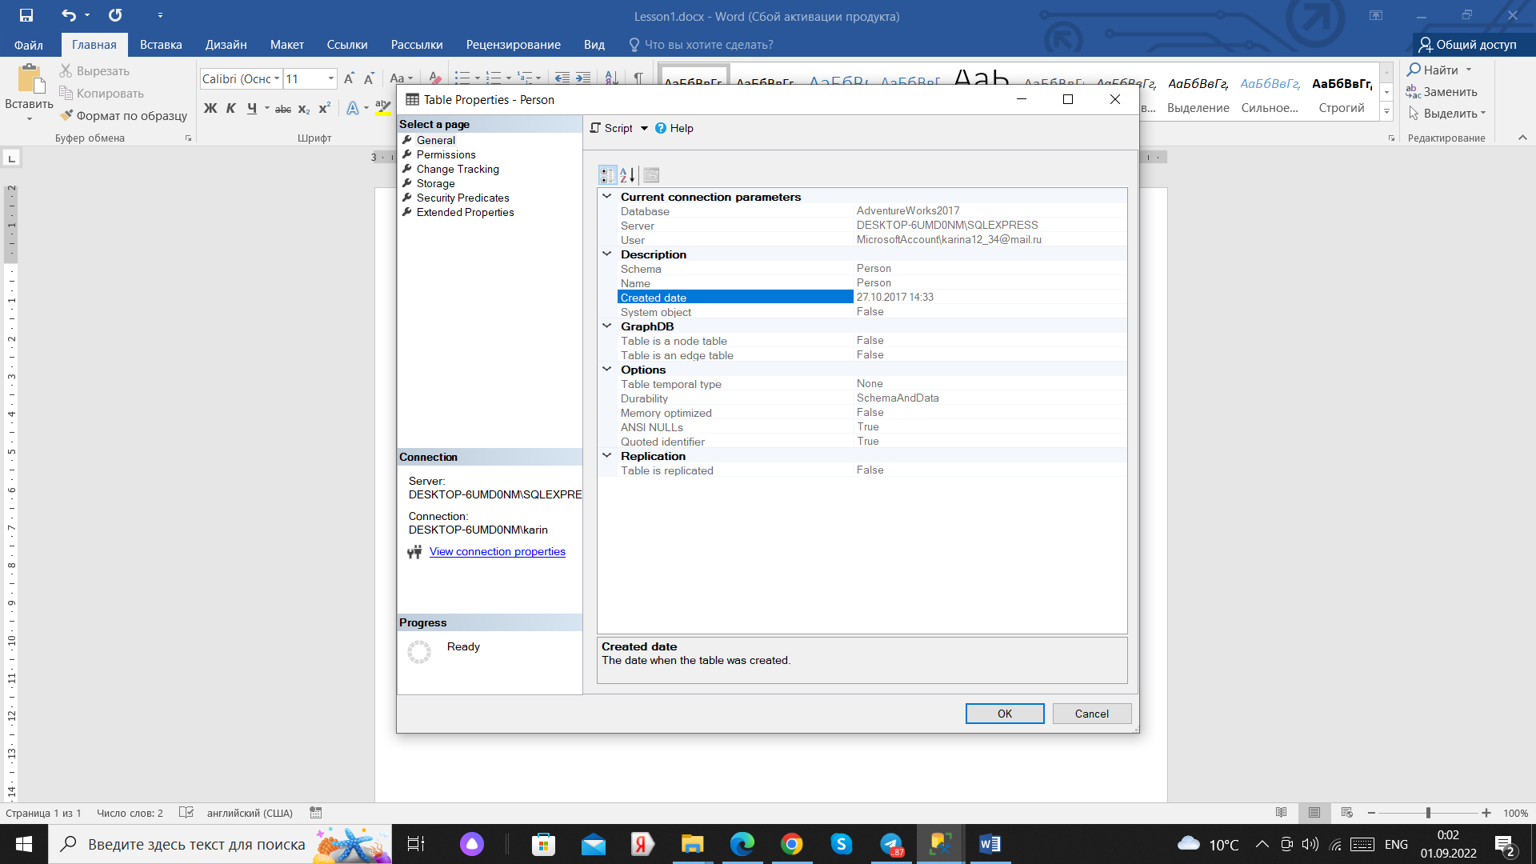

Task 4:

Answer:

0.008 MB = 8000 B

